Dataset case study questions

1. Analyze the dataset called dataset_shampoo, use the definition from the metadata (attached at the end) to answer the following questions. As you would have inferred the dataset contains Sales data: Value and Volume for a major supermarket related to the Shampoo category. Consider that you are the hair category manager for HealthMax supplier trying to analyze the data.
   1. How many brands on the market are owned by HealthMax
   2. For each healthmax brands calculate Year on Year growth rate. (Please google if you do not know the formula to calculate this)
   3. Calculate YTD Units and Sales for each Brand, Region, Year, Month. HINT: Use SUMIFs with the above criteria <https://www.ablebits.com/office-addins-blog/excel-sumifs-multiple-criteria/> (you can also ask ChatGPT for help)
      1. What are the YTD value sales for RedRose in 07/2018 for the central region?
   4. Calculate the Moving Annual Total (MAT) which is defined as the sum of Sales or Units for the past 12 months
      1. What is the total turnover of the total shampoo category in the latest 12 months?
   5. Calculate and identify the market share of the biggest players in the market.
      1. Analyze how our brands evolved over the years and if there were any regional differences – (answering questions like this is the key to your role as a Data Person)
      2. HealthMax owns Starbust and Shinez. In which region does Starbust have the biggest market share in 2023?
      3. How is the competitor FreshCo faring in terms of market share? Do you think they are a threat to us?
2. The over arching goal of this exercise is to suggest NRM strategies
   1. Research what NRM strategies are to get a better understanding: <https://www.bcg.com/publications/2017/consumer-products-pricing-how-net-revenue-management-boosts-top-bottom-line>
   2. 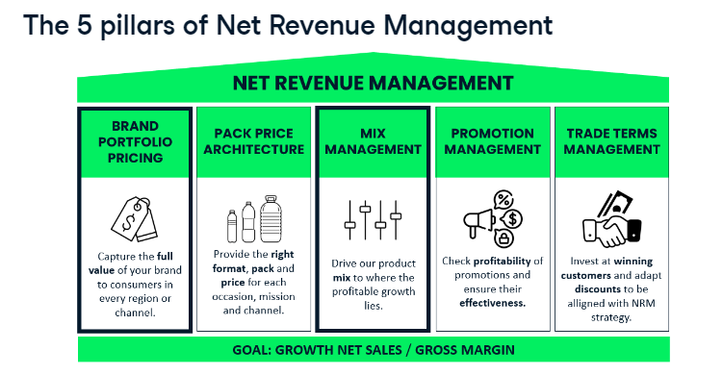HealthMax is looking for the best opportunity to increase the profit on one of its products. Please find below the current cost structure of that product:

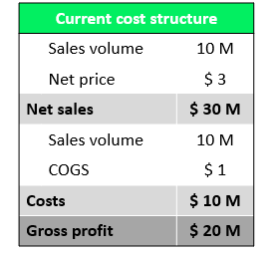

In this scenario what would increase the Gross Profit the most:

5% increase in Volume sales

5% increase in price

5% reduction in cost

Justify your answer and train yourself to think along these lines for analysis

1. HealthMax is looking to shift investments in between its products and is asking you to make a list of product prioritizations in function of their net sales and their profitability. Calculate the net sales for each product using the dataset internal_sales_data.
   1. What were the total Net Sales for Healthmax in 2022?
2. Calculate the gross profit per unit for each product on the same dataset, also calculate the margin
3. Calculate weighted average gross margin. What do you discover?
4. Find the Net Sales Contribution by dividing the Net Sales 2022 by the total of Net Sales 2022.
5. Using an appropriate visualization plot and analyze Net Sales Contribution against Gross Margin for each product. If you used a scatter plot you have created a profitability matrix. The purpose of this is to shift investments in between its products and determine a list of product prioritization in function of their net sales and their profitability.
   1. Which is the most important product in the assortment?
6. When looking at your your brand mix, you realize that HealthMax is only active in 2 out of the 5 shampoo subcategories and that it might be interesting to launch a new product to enter a new subcategory. To do so, you will identify the fastest growing subcategory (in units) and make an estimation of the total subcategory size for 2024.
   1. Use the data from the supermarket to do this analysis
   2. Make sure you calculate the growth in units and not in values and year is 2018 to 2022
   3. What category do you identify as the fastest growing since 2018
   4. Now that we determined the fastest growing subcategory, we would like to make a full year estimate of the size (in units) of this subcategory for 2024. Let's see what the latest yearly size of this subcategory was, using the Units MAT values for March 2023 (latest data available). Looking at the historic trend, you estimate that this category size for full year 2024 will be 20% higher than the March 2023 MAT values. Make an estimation of the total units sold in 2024 in your identified subcategory
   5. How many shampoo's will there be sold in 2024 in the fastest growing shampoo subcategory?
7. Now that you discovered that the category that is booming, your company has two possible products that fit in this category and that can be launched in the beginning of 2024. Let's identify the best candidate by making an estimation of expected net sales, gross profit, and gross margin for both products.
   1. Calculate the column Estimated units sold 2024, based on the market size you calculated in your previous exercise
   2. Estimate Net Sales per product, gross profit per unit and gross profit per product and gross margin
   3. Based on this information which product should be launched based on the NRM goal to maximise Gross Profit
8. You see that the smallest shampoo size in your portfolio is 100ml. Research has shown that people that travel are looking for shampoo bottles of 50ml. You contact your colleagues in other countries that do have a 50ml shampoo bottle in their assortment. They told you the small format is very successful and shared some assumptions so you can build your business case. Let's calculate the potential of a smaller shampoo bottle.
   1. Using the internal sales data calculate price per ml using the retail price

You decide to launch your best rotating product, the Starbust Ultra Soft 100ml, in a 50ml format.

* 1. To define the retail price, you can take a 50% mark-up of the Price per ml of the 100ml pack.
  2. The Net Price is $2.30 and the COGS amount to $0.70.
  3. Fill in the remaining columns in your table for this product and assume that the Volume 2022 will be 10% of the volume of the 100ml pack in 2022.
  4. **How much yearly net sales (in thousands) would the 50ml format generate estimated?**

1. 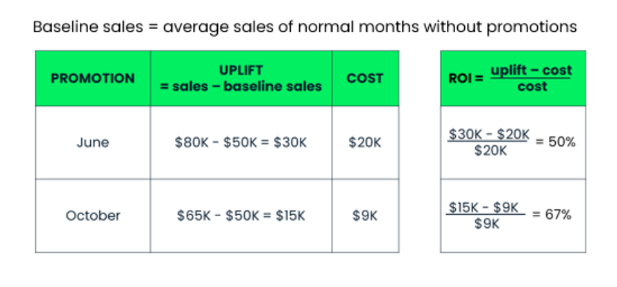Now we will analyze promotions:

1. HealthMax played three different promotions on the Shinez brand in 2022. To build the strategy for 2024, you'd like to come with clear recommendations of which promotions are the most effective ones. Let's calculate the ROI for the three different promotions from the data in promotion_analysis.
   1. Pick up value sales by month for Shinez from dataset_shampoo for 2022
   2. Calculate the Baseline Sales by taking the average Values Month of the months where no promotion was active.
   3. Calculate the generated Uplift per promotion.
   4. Calculate the ROI per promotion.
   5. Which promotion was most effective
2. Now that you calculated different opportunities based on the NRM pillars, it is time to wrap up and present the numbers to your management. You would like to present a waterfall graph to show how your initiatives will have an impact on the company's net sales of 2024. Let's start by making a forecast for the net sales in 2024 without our NRM initiatives. We'll base ourselves on the market sales until 2022, extrapolate the current trend until 2024 and calculate what it represents in net sales.
   1. Extrapolate for 2023 and 2024 using forecast.ets function in Excel, please research and understand the meaning of this function and take out values for 2023 and 2024
   2. Use the Net Sales to Market Value Ratio for 2022 to calculate Net Sales for 2023 and 2024 using the forecasted value * Same Ratio
3. Now for each initiative calculate the uplift
   1. Take 2023 Net Sales estimated from above
   2. Find out difference between 2023 Net Sales and 2024 Net Sales. Call this difference the natural growth
   3. Add the estimated sales for new category that we determined
   4. Add the estimated sales for the new sizing launch
   5. Show this in a waterfall diagram or otherwise
      1. 2023 Net Sales + Natural growth + New category product net sales +New sizing net sales
      2. This will be the new Sales for 2024 based on the NRM initiatives

**MetaData**

